M/V HAYDEN EVAN
56’ x 22.2’- 1,000 BHP Continuous Horsepower
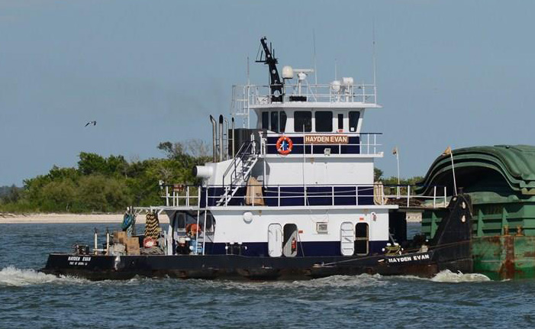

USCG Doc. No.: | 645159
Vessel Service: | TOWING VESSEL | IMO Number: | *
Trade Indicator: | Coastwise Unrestricted | Call Sign: | WDD2292
Hull Material: | STEEL | Hull Number: | 223
Ship Builder: | HORTON BOATS INC | Year Built: | 1982
 | Elmo Horton-Ala. | Length (ft.): | 52.2
Hailing Port: | HOUMA LA | Hull Depth (ft.): | 8.2
 |  | Hull Breadth (ft.): | 22.2
 |  | Gross Tonnage: | 86
 |  | Net Tonnage: | 58
TWIN SCREW - Cat 3408 diesels, repowered 2002, rebuilt 2015
Starboard Main Engine-Quality Diesel full overhaul in shop- 2,620 hrs
Port Main Engine- MidCoast Diesel Houston in-frame – 480 hrs.
Twin Disc MG- 518 red. (6.48:1) ; two GM 3-71 (30kw) gen sets
Props: Stainless Steel 62” x 58” four blade workhorse – 1,750 RPM dead push
Flanking Rudders/Steering Rudders/30 ton Electric Patterson Winches
Wabco Pneumatic Air Controlls/
Full fleet deck/ Elec Hydraulic Full Follow Up Steering; new swing meter
7,100 gals Diesel Capacity ; 9,000 gals fresh water Capacity
Two Staterooms, Full Galley, One Head, new Central AC compressor
Full Electronics _ Furuno Radar; VHF’s; Fathometer; Fire Alarm Panel
Varo Zeno stbd searchlight/ Port 1,000 watt Incandescent.

